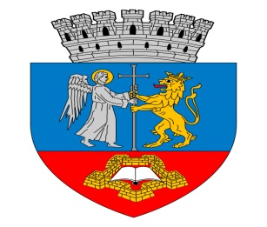
ENTRY FORM: Oradea / Romania 28 th September  (Saturday) 2019. | International Open Karate Championship  XVIII. Bihor Open - „ Champions Tournament”  „Shogunul” Trophy  Time: 09.00 – 20.00
Name of the Karate Club :  City: | -  -
Country : | -
Telefon / Phone number : | -
E-mail : | -
Website : | -
Responsible person : | -
Coaches / Team leader’sname: | -
Referees : | -
Entries please not later than 23.09.2019. on E-mail: secretariat.shogunul@gmail.com | By sending this Entry from I declare that all above listed competitors are in good health, capable of participating on tournament and in order to the medical conditions. Also we will take full responsibility for any possible injuries. I take responsibility for reality of the datas. I accept the entry conditions and I announce that the nominated competitors fit for the entry conditions.

Nr. | Name is surname of the competitor: | Date of birth | Weight (kg) | after sex  (M/F) | Individual  Kata Categories code: | Individual Kumite Categories code: | Team  Kata Categories code: | Team  Kumite Categories code:
1.
2.
3.
4.
5.
6.
7.
8.
9.
10.
11.
12.
13.
14.
15.
16.
17.
18.
19.
20.
21.
22.
23.
24.
25.

Data: ______________, 2019. _______. ___. ______________________
signature of coach / team leader

